Project ‘idea’ title
Key theme: Lake festivals, development of cooperation network | tourism

LAG name / Country: Tartu Rural Development Association/Estonia
Short summary of the project idea:  Lake Peipus is one of the biggest lakes in Europe (4th in the top ten), where exciting experiences lay within.  During Lake Peipus festival, various boats sail for eight days from one harbour to another. Each day the barge Jõmmu sails with the fleet to the port of destination where programs, introducing the region, take place. In each harbour, where the festival stops, different workshops are followed through, introducing local culture. Free concerts are held for the guests and local food is served.  This year, the festival is held for the third time. Each year the popularity of the festival and the number of participants have grown significantly.  The aim of this project is to use more navigation and to create greater acknowledgement for the region. For this cooperation project, we wish to learn from other peoples' experiences and pass on our own while organisizing an eight day festival. www.peipsifestival.ee  Possible acitivities of the international cooperation:  1. International Lake Peipus Festival in year 2019  2. Developing a network: trainings-study trips, where different people involved in water tourism, caterers etc. are involved  3. Trading with modern means  4. To promote using the lakes - navigation, festivals, culture etc. | 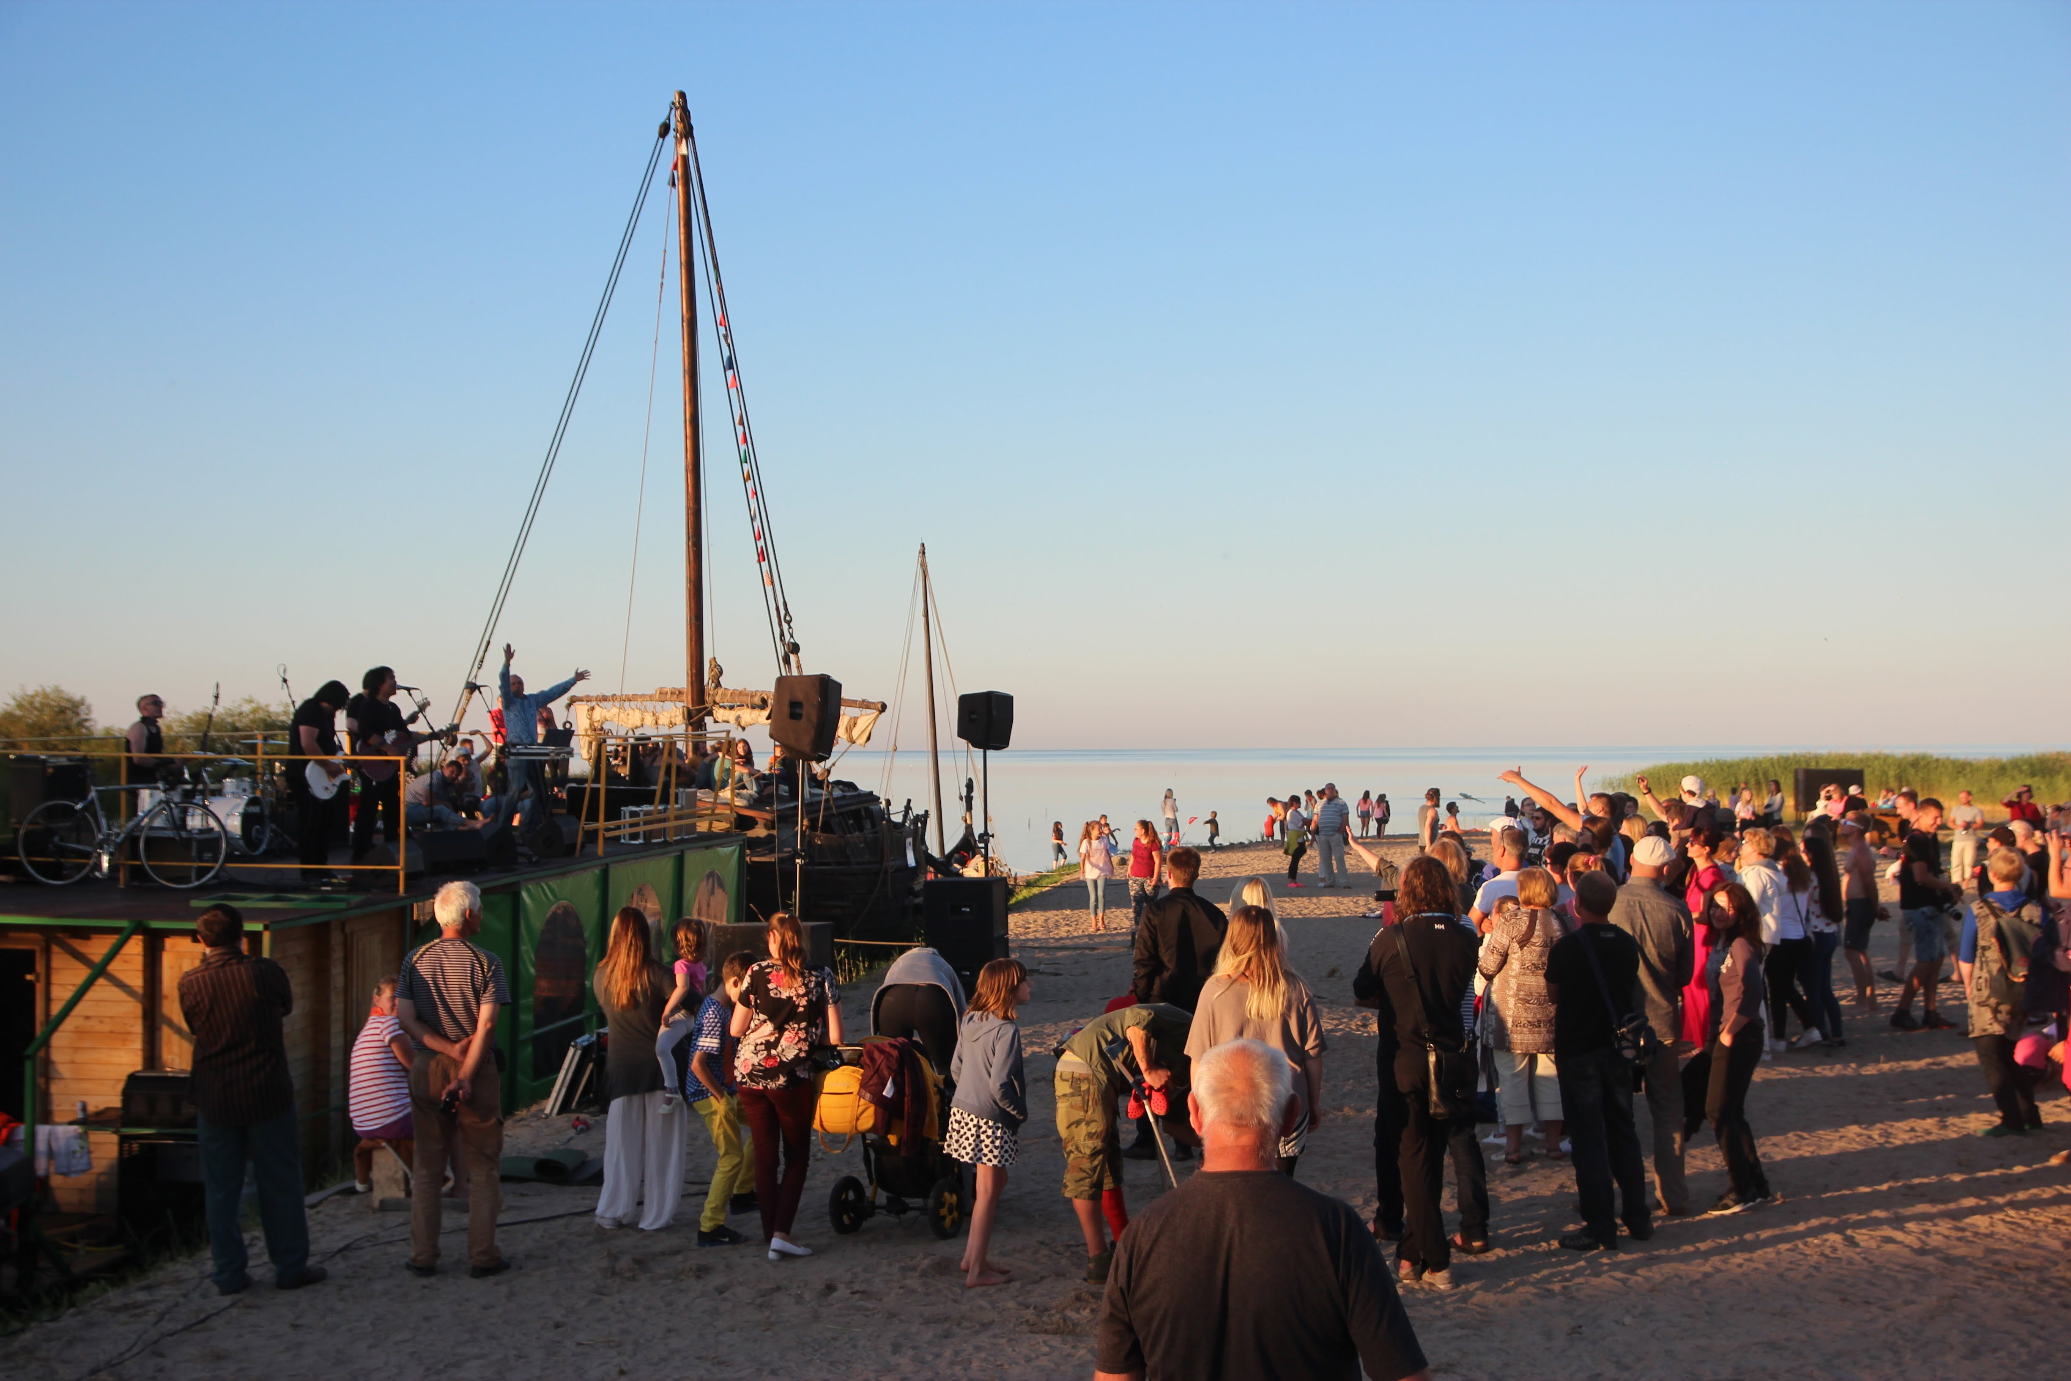  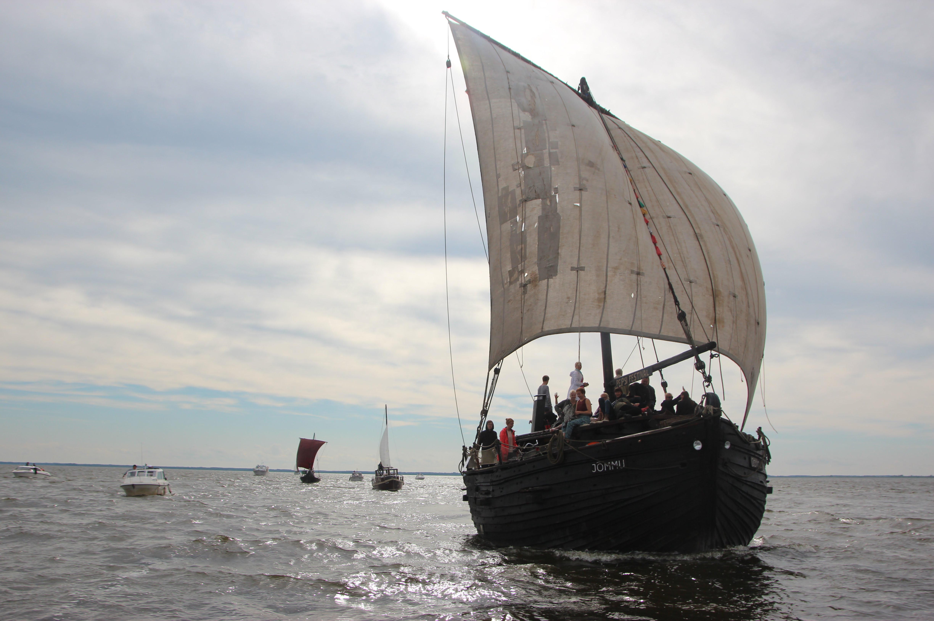

Contact person Kristiina Tammets

Email kristiina@tas.ee

Phone +372 5340 9873

Country or type of partner you are looking for Finland, Sweden, Italy, Germany, Poland

