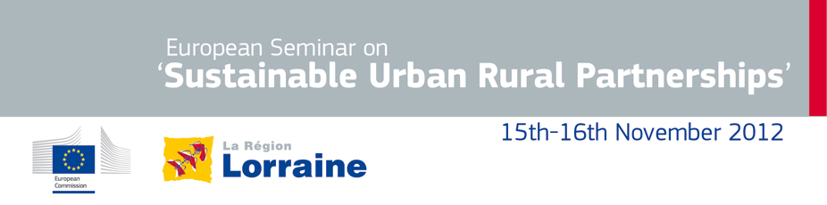

Dear Madame,
Dear Sir,

On behalf of the European Commission and the Lorraine region of France, it is our pleasure to invite you to the European seminar on "Sustainable Urban Rural Partnership" that will take place in Metz on November 16th 2012.

EU Member States and regions have now started preparing their Partnership Agreements and operational programmes to implement cohesion and rural development policy in the period 2014-2020. It is therefore important and timely to involve Europe's countries, regions and cities in a discussion on the role of rural-urban development in cohesion policy for 2014-2020, in particular how regional policy can help urban-rural partnerships foster regional growth and territorial cohesion.

The seminar on "Sustainable Urban Rural Partnership" will focus on three main themes:

1. Urban-rural partnerships: a new governance tool?;

2. Partnerships for sustainable rural-urban development: evidence on their effectiveness;

3. Improving rural-urban coordination: policy implications.

It will bring together two hundred participants, including European politicians and representatives of urban and rural networks, associations and European institutions.

The Lorraine Region would also like to invite you to a pre-seminar welcome session in the afternoon of November 15th in wich the region will present its own experience of integrated local development and integrated governance.

We thank you for your commitment and very much look forward to welcoming you in Metz for this important event.

Yours sincerely,

Veronica Gaffey  Director DG REGIO  Directorate for Policy Development |  |  | Jean-Pierre Masseret  President of the Lorraine Region

Please click the link below to learn more information about this event.
Click here for event summary


