 |  |  |  | 

University of Agriculture in Krakow –
European Research Centre For Small Agricultural Holdings

Agricultural Advisory Centre in Brwinów, Branch Office in Krakow

invite
to the 4th International Scientific Conference:

“Youth in Family Agricultural Holdings
and in Rural Areas in Europe”

which will be held in the Congress Centre of the University of Agriculture in Krakow on July 4-5, 2014

Prospective participants willing to submit their papers for the conference and/or publication are kindly asked to send a one-page abstract by the 15th of May 2014 to the following address: Conf2014@ur.krakow.pl or rutyran@cyf-kr.edu.pl

Also please, send the registration forms by the 15th of May 2014 to the
following address : Conf2014@ur.krakow.pl or rutyran@cyf-kr.edu.pl

With cooperation of:

 |  |  | Czesław Siekierski  Poseł do Parlamentu Europejskiego |  |  | 
 |  |  |  | 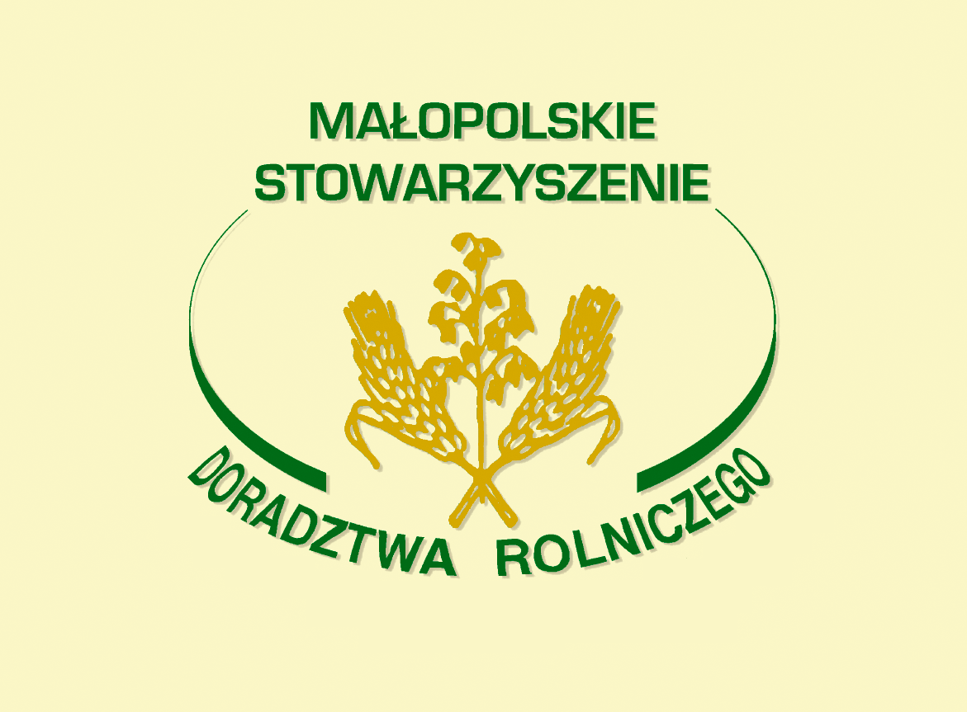 |  | 

