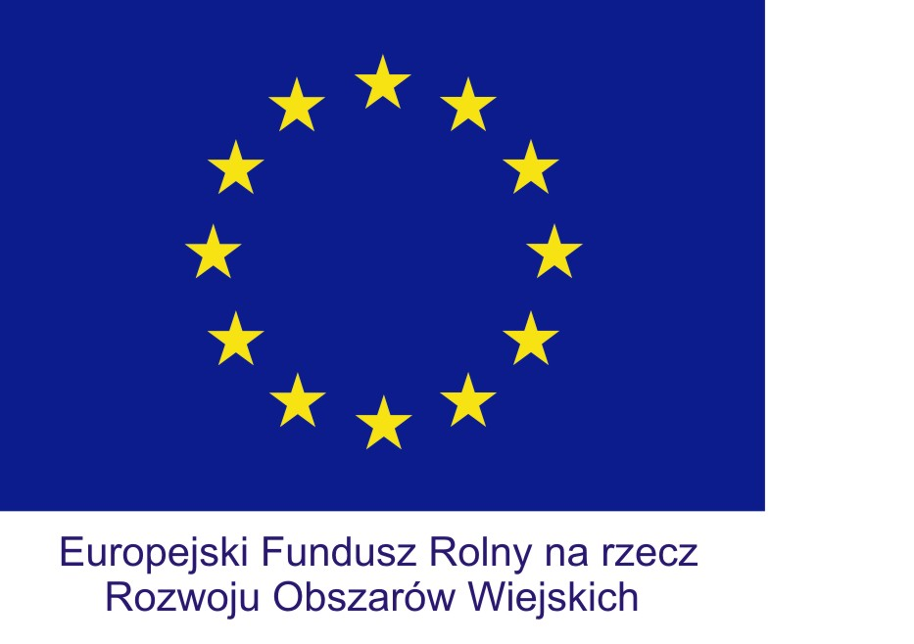 | 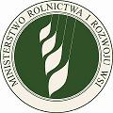 | 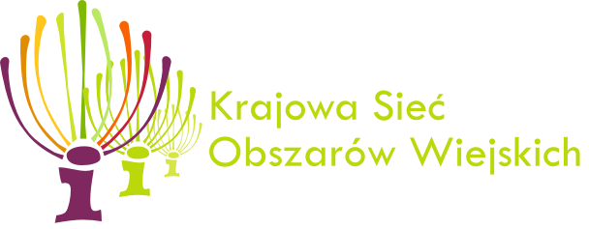 |  | 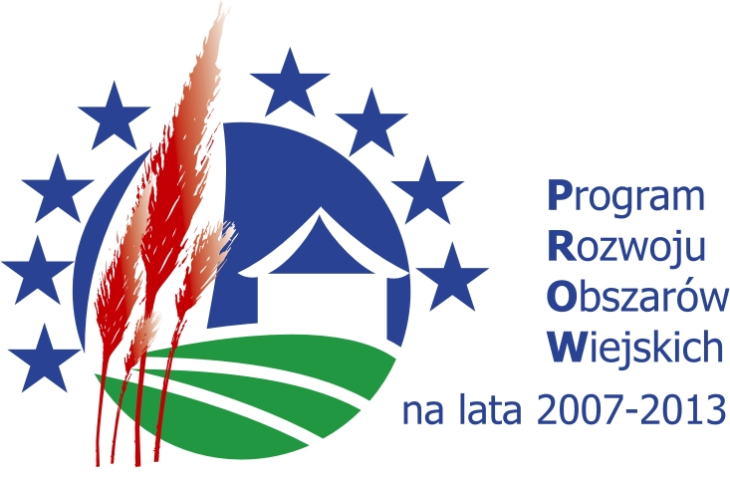
Invitation
Polish National Rural Network (Krajowa Sieć Obszarów Wiejskich) and the Ministry of Agriculture and Rural Development are pleased to invite you to take part in a study visit „AGRO TRIP”, which will be held on 4 - 8 April 2013 in central Poland that is in Mazovia and Świętokrzyskie regions.
The event is organised for the representatives of the national rural networks and their partners operating in the field of rural tourism, representatives of the European Network for Rural Development (ENRD) as well as for the governmental and self-governmental administration that influences the shape of rural development policy.
During the visit we would like to show you the Polish tourist products:
- Co-financed from the EU funds, including RDP 2007-2013;
- Implemented /managed in cooperation of partners from different sectors;
- Having impact on job market and on the quality of lives of rural areas inhabitants.
We would also like to invite you to take part in the international conference entitled „Tourist infrastructure as the element enriching rural areas offer”, which accompanies
the V International Rural Tourism and Agritourism Fair AGROTRAVEL, organised
on 5-7 April 2013 in Kielce. You are welcome to take part in the discussion during the conference. This year’s partner country of the fair is Finland.
The aim of the visit is to exchange knowledge and good practises in the scope of tourist infrastructure positive impact on development, functioning and integration of rural areas. This regards the projects of direct expenditure on tourist infrastructure following involvement of self-government, for examples, in building tourist objects, sports and recreation facilities, revitalisation and modernisation of historical and cultural buildings, tourist routes or tourist information systems. It also regards the projects of indirect expenditure designated for improvement of technical infrastructure within transport and environmental protection or serving development of services that improve the quality of lives of inhabitants and tourist attractiveness of rural areas. Comprehensive and multidimensional character of the projects will be even more important in the new programming period.
We provide the Polish-English interpreter, coach transport during the study visit, accommodation and board for the participants from 4-8 April (and only accommodation on 3 April for quests who are not able to reach the place of meeting before midday on 4 April 2013), free entry to the Fair Agrotravel and participation in the Polish traditional gala dinner on 5 April 2013. It is possible to departure earlier; that is on Sunday afternoon (7 April 2013) depending on convenient plane connections.
Please send your registration form by 6 March 2013 on the email address: A.Markuszewska@fapa.org.pl
You can find more information about AGROTRAVEL Fair on: www.agro.travel
More information about region: www.swietokrzyskie.travel/en
We cordially invite you to come to Poland and take part in AGRO TRIP.

www.ksow.pl

Draft times chedule of the visit:
4 April 2013 (Thursday)
Participants meet at 12.00 in Warsaw (near the entrance to the Museum of Technique in the Palace of Culture and Science)
Coach departure at 12.30-13.00
Journey to Kielce, including some stops on the way (visits and meetings with the “representatives” of tourist products in the Mazovia region and lunch
Dinner and accommodation in Kielce
5 April 2013 (Friday)
Breakfast
Participation in the international conference entitled „Tourist infrastructure as the element enriching rural areas offer”, which accompanies the V International Rural Tourism and Agritourism Fair AGROTRAVEL 2013 in Kielce (Kielce Trade Fairs)
Lunch and visiting the fair expositions/stands
Participation in the Polish traditional gala dinner at Łysogóry hotel in Kielce
Accommodation in Kielce
6 April 2013 (Saturday)
Breakfast
Departure from Kielce, including some stops on the way (visits and meetings with the “representatives” of tourist products in Świętokrzyskie region and lunch
Dinner and accommodation on the route of the visit
7 April 2013 (Sunday)
Breakfast
Departure to Warsaw, including some stops on the way (visits and meetings with the “representatives” of tourist products in the Mazovia region and lunch
Optional individual departure
Arrival in Warsaw in the evening
Dinner and hotel accommodation in Warsaw
8 April 2013 (Monday)
Breakfast, check out and departure

