THEMATIC GROUP ON LEADER BY THE NATIONAL RURAL NETWORK AS AN EXAMPLE OF GOOD PRACTICES
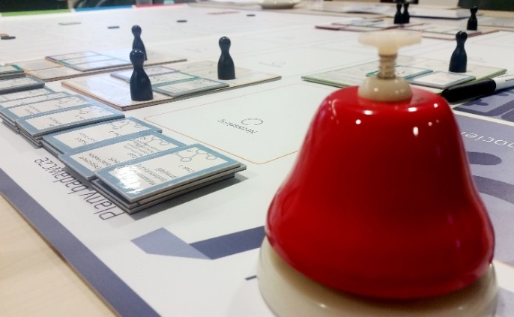
The Thematic Group on LEADER (TGL) was established on 12 October 2015 by a National Rural Network Working Group. Its main goal is to share thematic and analytic knowledge and to facilitate collaboration between NRN partners in the scope of LEADER.
The Group’s tasks include in particular:
- to consult NRN Operational Plans for the Measure „Training and actions for Local Action Group networking, including providing technical assistance in the scope of inter-territorial and transnational cooperation”;
- to identify good practices and experience in implementing LEADER at the national level and to make LAGs share experience with one another;
- to identify partners and cooperation projects in which Polish LAGs participate, to monitor and develop the cooperation;
- to reinforce the potential of people who implement LEADER/CLLD approach, including through sharing experience and good practices;
- to recommend LEADER approach publications at www.ksow.pl;
- to initiate cooperation and know-how exchange among entities involved in LEADER implementation, in particular to develop tools which facilitate cooperation and exchange of know-how.
A resolution establishing the TGL provides rules concerning its members, who include representatives of 16 regional LAG networks, 16 voivodeship governments as institutions implementing the Leader approach, RDP Managing Institution for 2014-2020, Agricultural Chamber and RDP 2014-2020 Monitoring Committee. After the first experiences and analyses of needs, the original number of the TGL members was increased for the TGL to fulfil - to the fullest extent possible - the Delegated Commission Regulation (EU) No. 240/2014 on the European code of conduct on partnership in the framework of the European Structural and Investment. The
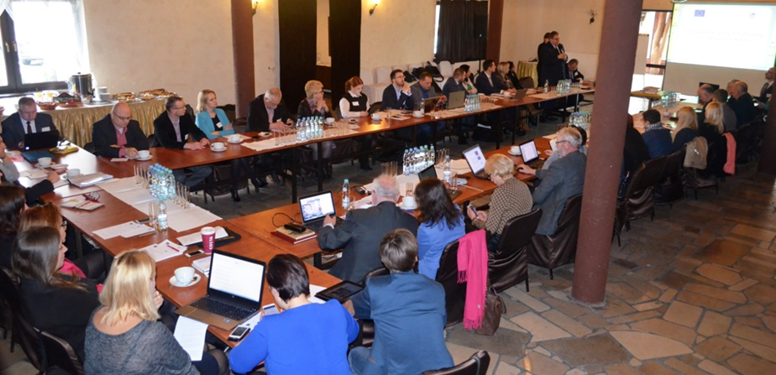
Group was increased to include a representative of an NGO which operates for the sake of community led local development and representatives of fishery local action groups (FLAGs). Moreover, the Group’s work is supported by geographical experts from ENRD and FARNET. Such a composition of the TGL facilitates sharing experience among all stakeholders involved in community led local development, while the voice of LAGs is heard at local government offices and legislative bodies. Currently, the TGL includes 46 members. The role of the Group’s secretary is fulfilled by the Central NRN Unit. The President of the Group was nominated by the Polish LAG Network.
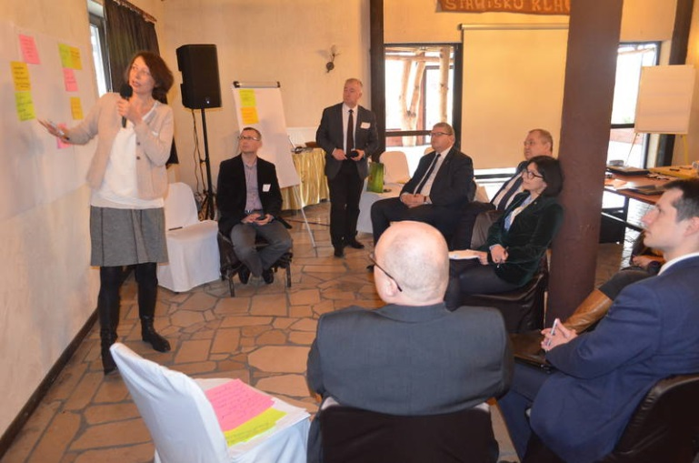
The Thematic Group on LEADER meets at least 4 times a year (once a quarter). Its role is to give opinions and advice, its postulates and recommendations being presented in the form of positions and resolutions. The form of meetings depends on the needs and scope of the agenda. External experts are invited to participate if necessary. Issues on the agenda to-date, according to the Group’s tasks, related to giving opinion on NRN’s operational plans (including operation selection criteria), participation of LAGs representative in international meetings concerning LEADER, as well as LAGs’ tasks during the 2014-2020 programming period. The TGL is not only a platform for exchange of know-how and information; it is also an opportunity to share experience, discuss successes and problems as well as tools for spreading the former and eliminating of the latter. Members of the Group participate in workshops organized during meetings. One of the workshops concerned a possibility to include LAGs in implementing the cohesion policy goals. Interactive methods were used to work out common recommendations for broader implementation of CLLD in Poland in various forms, with the help of funds from the European Fund for Regional Development and European Social Fund. Interactive method was also applied in order to develop the TGL position concerning the carrying out of NRN operations.
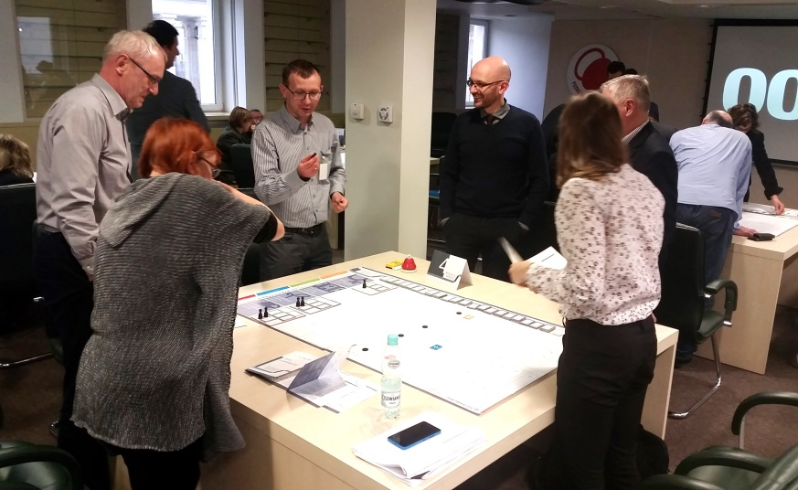
During workshops concerning LDS evaluation, the importance of monitoring for effectiveness of actions taken in the framework of LDS was presented in a practical way. Participants learned that appropriately constructed monitoring and evaluation system benefits actions taken by LAGs. The method of conducting the workshop helped show key elements of monitoring and evaluation process; moreover, the workshop participants learned about a variety of evaluation methods. The workshop scenario was based on a simulation game.
The TGL members (representatives of LAGs and voivodeship authorities) could also participate in a special workshop, which aimed at defining constraints and difficulties in implementing actions delegated by RDP 2014-2020, CLLD and LDSs. During the workshop the participants worked out proposals of actions for eliminating or reducing the constraints, as well as rules which ensure good cooperation between LAGs and the remaining stakeholders involved in LEADER implementation, i.e. Managing Authority, Paying Authority and Implementing Authorities.
Representatives of regional LAG networks could also notify LAG training needs in their voivodeships. On this basis the TGL passed a resolution recommending themes and methods of training sessions conducted under NRN Plan for groups all around Poland. This will enable real needs of LAGs to be addressed more precisely.
The TGL’s mission also includes promoting information concerning LEADER featuring international meetings and events. In this way, the TGL members were relayed information from numerous ENRD initiatives or Member State networks, such as i.a. CLLD seminar in Sweden, meeting of LEADER/CLLD subgroup by ENRD and work of CLLD group within the RDS Monitoring Committee for 2014-2020. The TGL may nominate its representatives to take part in events organized by ENRD or by networks of other Member States, e.g. ENRD workshop concerning social inclusion or workshop on LEADER innovativeness.
A Task Force including 7 LAGs representatives was appointed within the TGL; it is to streamline procedures prepared by Paying Agency for implementing LDSs and make them more transparent. The Task Force participates in developing procedures under LEADER, it e.g. consults model application documents under M 19.2, including draft agreement for funds, or draft changes to a business plan. Currently, the Task Force members are involved in analysing problems which appeared after the first calls for proposals, including issues such as register of interests, protests, limits.
Reports from all the TGL meetings, together with presentations and materials, are posted on NRN website and on Facebook. Information is also provided to a LAG discussion group on Facebook, which includes over 300 participants representing approx. 200 LAGs. Moreover, TGL President reports on the Group’s work during the meetings of NRN Working Group.
The organizers and participants of meetings have managed to work out such a formula of the meetings that they are not only a place to learn, but also a place to share experience. It was also possible to create an atmosphere of trust, where all participants listen to each other and notify the most important problems. As Ryszard Zarudzki - Undersecretary of State in the Ministry of Agriculture and Rural Development - said while welcoming the participants of the 5th meeting of the Leader Thematic Group: The two most important things are cooperation and a dialog about what is difficult and also about what is good. On the other hand, according to Janusz Bartczak, who presides over the Polish LAG Network: the TGL is a marvellous tool for developing cooperation and sharing know-how among all the LEADER environment. This is a tool which manages to combine substantial knowledge of the approach with experience and skills of rural leaders. Thus, it avoided the fate of many other committees and has become a genuine platform for a dialogue and a place of learning. This is just what the TGL is about.

