CLLD Cooperation OFFER

Title of the proposed project (English)

Outsider art -Developing trade and tourism

Type of project (select as many as you want)
Cooperation within the MS  ☐ Across regions  ☐ Within the same region | Transnational cooperation  x☐ Cross-border cooperation  ☐ With other MSs (no shared border)  ☐x Non EU countries | Sea basin cooperation  ☐ Mediterranean  ☐ Baltic  ☐ North Sea  ☐ Atlantic

Brief summary of the project idea (max 800 characters)
The purpose of the project is to create channels for outsider art (https://en.wikipedia.org/wiki/Outsider_art) for this form of art to be traded and used as attraction at the regions involved in the project.
Duration Suggested timeline is that project starts in May 2017 and continues until autumn 2018.
Results
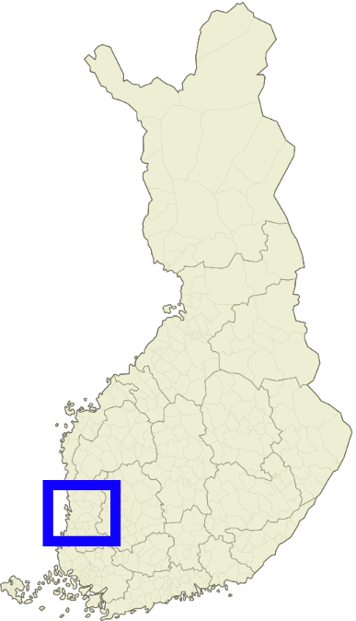
The project results are
- publicity to outsider artist
- art trade structure is created
- network of outsider art agencies and artists are strengtehed
- creating tourist attraction
Actions 1) Local actions
a. Searching and contacting a region’s artists
b. Exhibition at Satakunta
c. Documentary film
d. Travel to partners
e. Webpage in Finnish English

2) Common actions
a. Co-operations with the documentary film
c. Exhibition’s design
d. Joint conference and opening events of exhibitions

Looking for partner located in the following types of areas (select as many items as you want)
x☐ National / Regional borders  ☐x Inland  ☐x Island  ☐x Lakes and rivers  ☐ xCoastal  ☐ xMountainous | x☐ Rural  ☐x Peri-Urban  ☐x Urban  ☐x Small town  ☐x Historic centre  x☐ Densely populated residential area  ☐x Segregated/deprived neighbourhood | x☐ Isolated / remote  x☐ Sea basin  ☐x Mediterranean  ☐x Baltic  ☐x North Sea  ☐x Atlantic

Looking for partner located in areas with the following assets (select as many items as you want)
☐ x High Nature Value  ☐ x Cropland  ☐ x Pasture | ☐ xForest  ☐ x Non-productive land  ☐ xIndustry | ☐ x Presence of relevant cultural sites  ☐x Mineral extraction  ☐ x Protected areas

Topic of the project (select up to 10 items)

☐ x Innovation  ☐x Research & Development  ☐ New technologies  ☐ x Knowledge transfer / education / training activities  ☐ Broadband / Internet / ICT  ☐x Culture and Cultural heritage | ☐ Built environment  ☐ Village, harbour renewal  ☐ Public / community spaces / green areas  ☐ Energy efficiency, retro fitting buildings  ☐ Reconversion brownfield areas  ☐ Rural infrastructures  ☐ Social inclusion / Public services  ☐x Integrated service delivery  ☐ Social services  ☐ Transport & Mobility  ☐ Education  ☐ Health  ☐ Housing  ☐ Anti discrimination  ☐ Social enterprises  ☐ Employment / job creation  ☐ Access to labour market  ☐ Work-private life reconciliation  ☐ Self-employment  ☐ Upskilling  Target groups:  ☐x Youth  ☐x Women  ☐x Long term unemployed  ☐x Homeless  ☐x Elderly  ☐x Migrants  ☐ Fishermen  ☐ Marginalised communities e.g. Roma  ☐ People with disabilities  ☐ Ex offenders  ☐ Others
☐ Agriculture & Farming
☐ Small farms
☐ Semi-subsistence farming
☐ Organic farming
☐ Livestock
☐ Animal welfare
☐ Young farmers
☐ Urban farming
☐ Fisheries and aquaculture
☐ Fisheries
☐ Aquaculture
☐ Forestry
☐ Food & Drink
☐x Marketing
☐ Supply chains / Producer organisations & Cooperatives
☐x Non-food products / Crafts
☐x Business development
☐x Economic diversification
☐x Tourism / Territorial branding
☐x Natural environment & Resources / Landscape
☐ Climate change mitigation / adaptation
☐ Local energy production / renewable energies
☐ Circular economy / bio, green economy
☐ Governance
☐ Community development
☐ Rural Urban linkages
Additional keywords: (up to 3)

Objective
Initial position / background / local context of the proposed project (max 800 characters)
The starting situation or local context in which the projects is going to operate
The basic setting is that outsider artists do not necessarily involve themselves into galleries and trade, which are part of what they are outside of. Authencity of this form of art is one of its great benefits to the art in general. Outsider art may not be for everyone, but it has a lot of enthusiasts and great potential to develop more enthusiasm if it were to be known more widely. Also outsider art is attractive to both art professionals and those who are not so art oriented to begin with. Threshold go to see art is low and also this form of art touches people mind-settings very easily.
In Finland, outsider art has quite some recognition, even if not yet very generally known. Finnish museum of Contemporary Art (http://www.kiasma.fi/en/) had an exhibition of outsider art as early as 2005.

Proposed objectives / target group and activities (max 800 characters)
The project, thus,
1) aims to create webpage and a documentary film in English. This enables, at least in theory, the involved regions’ outsider art to be at reach globally.
2) Another point of action is to organise exhibitions (in the limits of regions’ own interest) that would attract local, national and international interest and thus promote regions’ outsider art. A longer term perspective is to create art dealership via internet and support of create frequent or permanent exhibition activities at the regions.
The initiation of the project is open to discussions and chances as partners come along. The latter year is for exhibitions, the first year for other activities; searching artists, planning and executing the film, planning exhibitions and meeting partners.

Country and /or kind of partner you are looking for (ALL EU in case the interest is on any EU country)
all

Languages spoken by your LAG staff

Offering LAG

Contact details
Member State | Finland
Region | Satakunta
LAG name | Karhuseutu
Contact name | Jaana Mälkki
E-mail | jaana.malkki@karhuseutu.fi
Tel. | +358440926926
LAG Address

This Cooperation Offer is valid until
This is a mandatory field! Please provide a date after which the cooperation offer will not be valid anymore.
May 2017

Date: _ _ _ _ _ _ _ _ _ _ _ _ _ _ _ _ _

