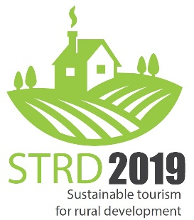
PROGRAMME
Vers. 190115

Thursday, 14th-February
Joint evening event with the Seminar on Experiential Tourism during the same day.
Public roundtable, declaration, etc. together with representatives from the Experiential Tourism seminar - tbd (in relaxed format)

Friday, 15th-February
Time | Programme item
9:00 | Inauguration and welcome notes
9:10 | Challenges for rural areas: digitalization, demography, accessibility  - Digitalization - tbd  - Active Ageing – AGE Platform  - Accessibility of tourism services – ENAT  Practical case: from Ireland
10:40 | Coffee break
11:00 | Opportunities for rural areas through tourism: landscape, authenticity, nature, new markets for local produce  - Nature Parks  - Landscape association  - Distribution of eco and local products – Farmidable  Practical case: EGWA – European Greenways
12:30 | Lunch
13:30 | Ways forward: Smart territories, new CAP, local and cross-sectorial cooperation  - ELARD (tbc)  - DG GROW (tbc)  - (two private transnational entities)
15:00 | Coffee break / Opening of the Fair
15:30 | High-level Roundtable  - Ministry of Agriculture and Tourism (IT) - tbc  - Rep of COPA-Cogeca  - Mr. Gérard Peltre - MER  - Mr. Tim Fairhurst – ETOA and NET (European Tourism Industry umbrella)  - Rep of international body (tbd)  - European Parliament
17:00 | Winners Marketplace - Conclusions
17:30 | Closure

NOTE: this sequence Opening of the fair at 15:00 hs that is immediately followed by the high-level round table of public and private authorities.

