International seminar
Rural development and CLLD
12 -13th September 2018
Valmiera, Latvia
Field trip routes on September 12
Route No.1. “Circle Limbaži”
Registration 09.30, departure at 10.00
from Hotel “Tigra” (address: Eduarda Veidenbauma iela 2, Cēsis/ Priekuļi, Priekuļu pagasts, LV-4126)
- Ltd “Latnature” – company produce chips from berries and vegetables
(LEADER project)
http://www.rauna.lv/turisms/tourism/latnature-ltd-vegetable-crisps-manufacturer
https://www.facebook.com/Latnature/
(address: Cēsu iela 10-1, Rauna, Raunas pagasts)
- The historical site “Straupe horse mail”
Local slow food market place famous all around Latvia.
(LEADER project)
https://zirgupasts.lv/
(address: "Vecpasts", Straupes pagasts, Pārgaujas nov., LV-4152)

- Limbazi Historical Center, renovation for development of the tourism.
(European Regional Development Fund project)
http://travelnews.lv/foto/?gid=3891&iid=72813
(address: Rīgas iela 16, Limbaži, Limbažu pilsēta, LV-4001)

- Ltd. “Krogzeme”
Produces ORGANIC blackcurrant seedlings on order in large quantities for blackcurrant plantations.
(RDP Project)
https://www.latvijasupenes.lv/home/
(address: Krogzeme, Stādaudzētava, Vīnkalniņi, Limbažu novads, Ķirbiži, LV-4050)
Arrival at guest house “Brūtes pļavu būtes” (address:“Brūtes pļavu būtes”, Mūrmuiža, Kauguru pagasts, LV-4224)
From 19.10 till 19.50 time for transnational cooperation.
At 20.00 starts social dinner.
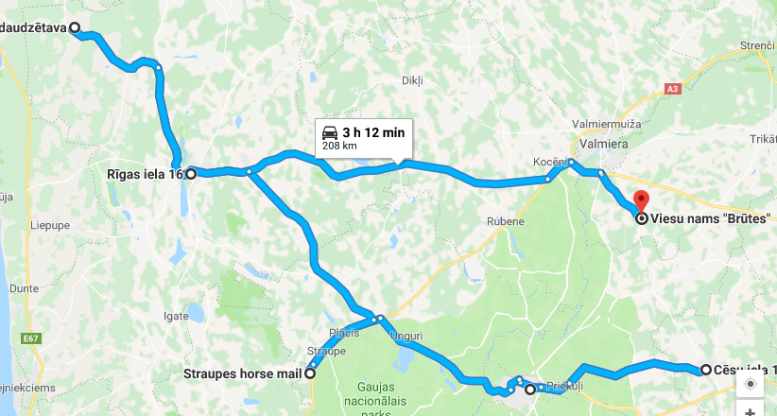

Route No.2. “Circle Smiltene”
Registration 09.30, departure at 10.00
from Hotel “Naktsmājas” (address: Vaidavas iela 15, Valmiera)
- Dairy farm “Kalējiņi 1”
Intensive investment in development of the dairy farm.
(RDP project)
https://www.facebook.com/kalejini1/
(address: Mēri, Bilskas pagasts, LV-4706)

- Farm “Veccepļi”
Apple growing and juice processing factory.
Implemented projects are for the development of production.
(LEADER project)
https://aboli.lv/
(address: “Cepļi”,Palsmanes pagasts, LV-4724)

- Ltd”Tālavas ķēniņa alus”
Beer brewery.
(LEADER projects)
http://www.talavas.lv/#
(address: Rairu, SIA Kalēji, Gulbenes novads, Lizuma pagasts, LV-4425)

- Technological change in sawing process Ltd “Smiltene Impex”, introducing new technologies
(European Regional Development Fund)
(address: Smiltene Impex SIA, Silvas kokzāģētava, Launkalnes pagasts, Smiltene, LV-4729)
Arrival at guest house “Brūtes pļavu būtes” (address:“Brūtes pļavu būtes”,Mūrmuiža, Kauguru pagasts, LV-4224)
From 19.10 till 19.50 time for transnational cooperation.
At 20.00 starts social dinner.
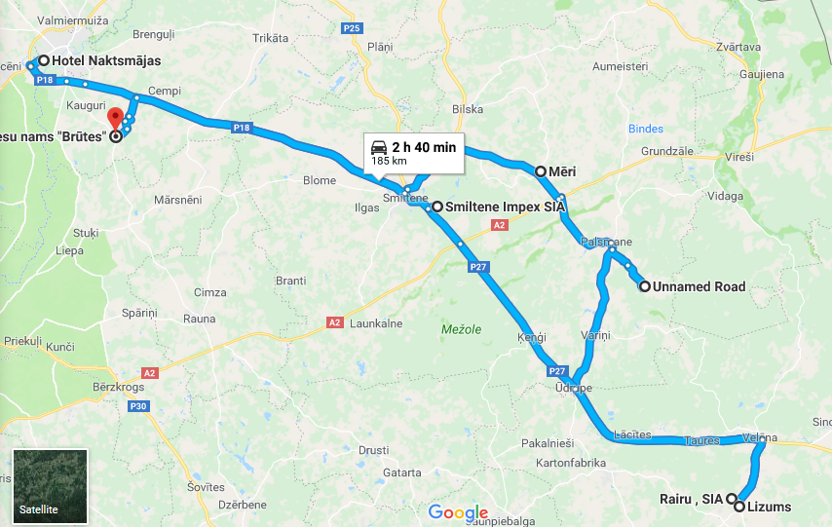

Route No.3. “Circle Valmiera”
Registration 09.30, departure at 10.00
Departure place will be confirmed.
- Dairy farm “Ceriņi”
Intensive investments in development of the dairy farm.
(RDP project)
https://www.facebook.com/zsCerini/
(address:“Ceriņi”, Jeru pagasts, LV-4234)

- Ltd”Valmiermuižas alus” beer factory
(RDP project, European Regional Development Fund project)
http://www.valmiermuiza.lv/en/
(address: Dzirnavu iela 2, Valmiermuiža, Burtnieku novads)

- BMX track and museum
(LEADER project)
http://www.bmxtalava.lv/en/sco-centrs-bmx-velotrase
(address: Avoti, Valmieras pagasts, Burtnieku novads)

- SIA “WoodHeart”
(LEADER project)
http://woodheart.lv/?lang=en
Modern design wooden furniture production.
(address: Burtnieku nov., Valmieras pag., Valmiermuiža, Alejas iela 12/3, LV-4219)

Arrival at guest house “Brūtes pļavu būtes” (address:“Brūtes pļavu būtes”,Mūrmuiža, Kauguru pagasts, LV-4224)
From 19.10 till 19.50 time for transnational cooperation.
At 20.00 starts social dinner .
