International seminar
Rural development and CLLD
12th – 13th September 2018
Valmiera, Latvia
Practical information
Date:
12th and 13th of September, 2018
Language:
The working language of the meeting will be English and Latvian.
Participants:
Participation is limited to 150 participants. Please do not book your flight before confirmation of your participation.
Venue
The seminar will take place in Valmiera Cultural Center, Rīgas iela 10, Valmiera. City is located in the East-North side of Latvia, around 110 kilometers from Riga.
Hotel rooms are provisionally reserved in two hotels in Valmiera and one in Cēsis/ Priekuļi.
How to get to the venue
From Riga International airport to the Riga Center
Bus
If you came by plane you should arrive to Riga International airport and take the bus Nr.22, every 10-20 minutes, and get to the station “Autoosta”(see map below).
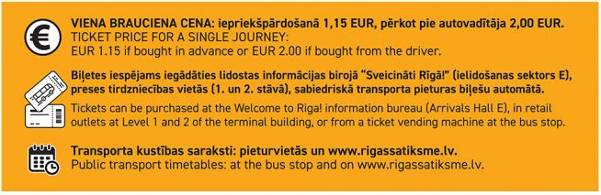
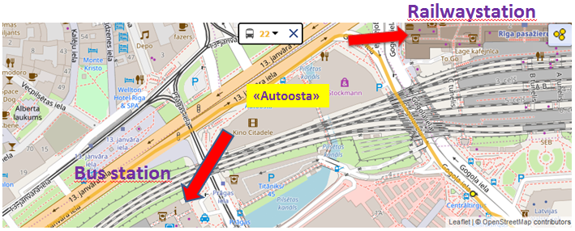
Taxi
Taxi from the airport to Riga center will cost around 15 EUR. There are several taxi options, but we would recommend to use “Baltic Taxi” http://baltictaxi.lv/en/call-taxi.html or “Red cab” http://redcab.lv/?lang=en
You can also get voucher for “Baltic Taxi” in the arrival hall.
At first check the journey price before getting in taxi.
From the Riga center to Valmiera
City location allows to get from Riga center to Valmiera by bus or train, journey costs around 5 EUR and takes 2 – 2,5 hours.
Bus timetable: https://www.1188.lv/en/transport/buses/rigas-sao/valmieras-ao/105317/105331/day/2018-07-25
Train timetable: https://www.1188.lv/en/transport/trains/riga-pasazieru/valmiera/100001/100132/day/2018-07-24
When in Valmiera, we recommend you to take taxi to get to your hotel, travel costs depends from hotel location, 5–10 EUR.
At first check the journey price before getting in taxi.

From the airport directly to Valmiera by taxi
There are several taxi options, you can share a taxi or minibus already from the airport. It will cost you around 100-110 EUR.
“Green Express taxi”: https://www.1188.lv/en/catalog/taxi-5830/green-express-taksometru-pakalpojumi-airport-transfers-809499
You can order before by e-mail: sia.greenexpress@gmail.com, phone: 20012103
Also you can take “Baltic Taxi” or “Red cab” taxis which are in front of the airport.
At first check the journey price before getting in taxi.
From Riga center to Cēsis
If you stay in Hotel “Tigra”, you have to travel to Cēsis.
Journey costs around 4,15 EUR and takes 2 hours to get there.
Bus timetable: https://www.1188.lv/en/transport/buses/rigas-sao/cesu-ao/105317/105255/day/2018-07-24
Train timetable: https://www.1188.lv/en/transport/trains/riga-pasazieru/cesis/100001/100020/day/2018-07-24
You can take the same taxi service: “Green Express”, “Baltic TAXI”, “Red cab”.
Cēsis bus and train stations are 24 min walk from Hotel “Tigra.”
Field trip on 12th of September
The field trip on 12th of September is optional. Registration for field trip will start at 09:30, buses will leave at 10:00 from the hotels mentioned in “Field trip agenda”. More details are provided into “Field trip agenda”. Completed information about routs will be sent couple of days before event.
Seminar on 13th of September
The organizers will provide transport from hotels to conference venue on 13th of September.
• Buses will leave from hotels to seminar venue:
- 08:00 from Hotel “Naktsmājas” in Valmiera
- 07:40 from Hotel “Tigra” in Cēsis/ Priekuļi
- 08:00 from Hotel “Bestes Apartment” in Valmiera

Accommodation:
Due to the limited number of single rooms, we suggest you to share a room with colleagues.
Please book your accommodation directly at the preferred hotel. At booking please use the code “RURAL” for the reserved rooms till the 28th of August.
There is also possibility to book other hotels in Valmiera which are not pre-reserved https://ej.uz/oc82
For those who choose field trip route No.1 “Circle Limbaži” we recommend to choose Hotel Tigra, in Cēsis/ Priekuļi.
More information: https://hoteltigra.lv/ choose “book now”.
Book hotel by e-mail: reservations@hoteltigra.lv or phone: +371 64174040, +371 65674334.
Address: Eduarda Veidenbauma iela 2, Cēsis, Priekuļi, LV-4126, Latvia.
Map from Cēsis bus and train station to Hotel “Tigra”:
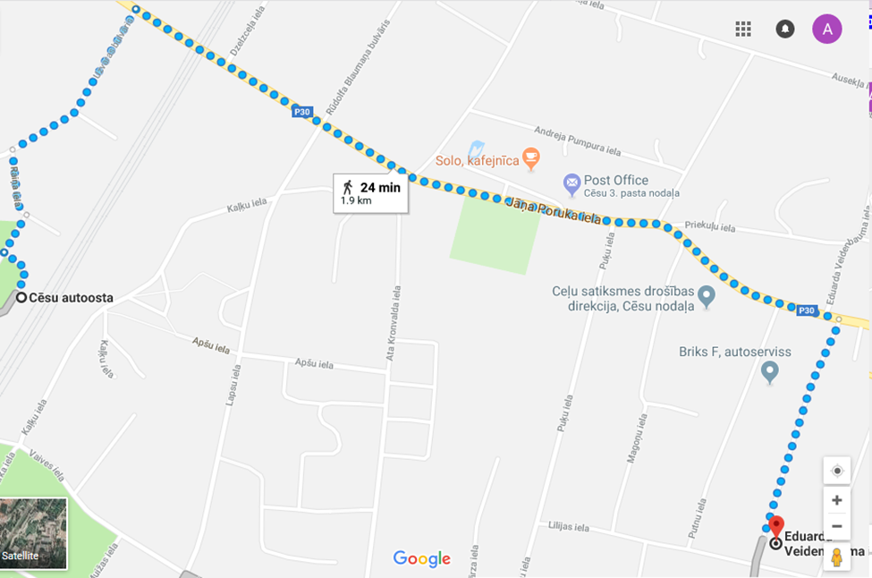
For those who choose field trip route No.2 “Circle Smiltene”, we recommend to choose Hotel “Naktsmājas”.

- 6 twin rooms (Separate beds, en-suite facilities, TV, fridge, telephone, hairdryer) 1 pers. – 50.00 EUR, 2 pers. – 60.00 EUR.

- 7 double rooms for single use (Double bed, en-suite facilities, TV, fridge, telephone, hairdryer) 1 pers. – 50.00 EUR, 2 pers. – 60.00 EUR.

- 4 junior suite (Double bed, living room, en-suite facilities, in living room TV, fridge and telephone) 1 pers. – 60.00 EUR, 2 pers. – 65.00 EUR
- 14 family rooms (2 bedrooms, 4 separate beds, en-suite facilities, hairdryer, TV, fridge and telephone) 1 pers. –35.00 EUR, 2 pers. –55.00 EUR, 3 pers. –80.00 EUR, 4 pers. -100.00 EUR.
All rates include breakfast (buffet service).
Check-in from 3 pm. Check-out till 11 am, but in holidays till 12 am.
All rooms have Wi-Fi Internet connection.
Book hotel by e-mail: info@naktsmajas.lv or phone: + 371 25464433
More information: http://naktsmajas.lv/index.php/homeen/8-service#
Address: Vaidavas iela 15, Valmiera, LV-4201.
Map from Valmiera bus station to Hotel “Naktsmājas”:
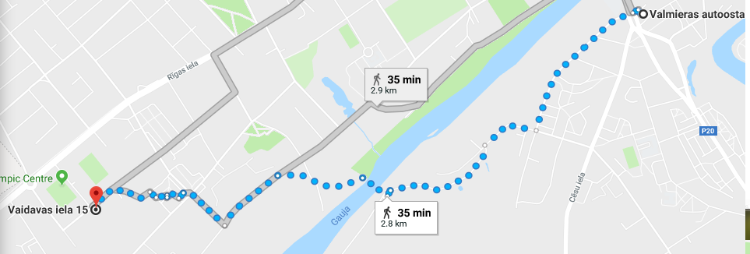
Map from Valmiera Railwaystation to Hotel “Naktsmājas”:
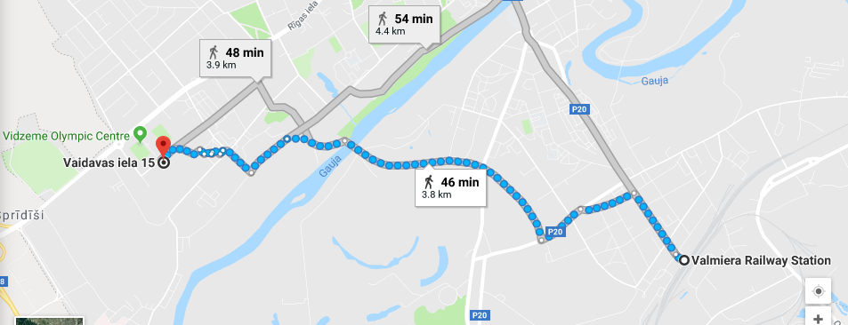
Hotel “Bestes Apartment”
Bestes Apartment is new apartment type hotel, which will be open to host guests in September 2018.
Hotel offers accommodation in Koceni, 5km from centre of Valmiera.
Bestes Apartmenti offer:
- 2 Twin rooms (for 2 adults), for 1 person 30 EUR, for 2 persons 60 Eur.
- 10 Standard Quadruple rooms (for 4 adults), for 3-4 persons 60 Eur.
Hotel provides free private parking, free WiFi, each apartment includes private bathroom, kitchenette, WC, TV.
Hotel does not offer breakfast, we will organize it separately.
Book this hotel by e-mail: iveta.brunina@gmail.com
Address: Bestes apartamenti, Bērzu iela 5,Kocēni, Kocēnu novads.
Map from Valmiera bus station to Hotel “Bestes Apartment”:
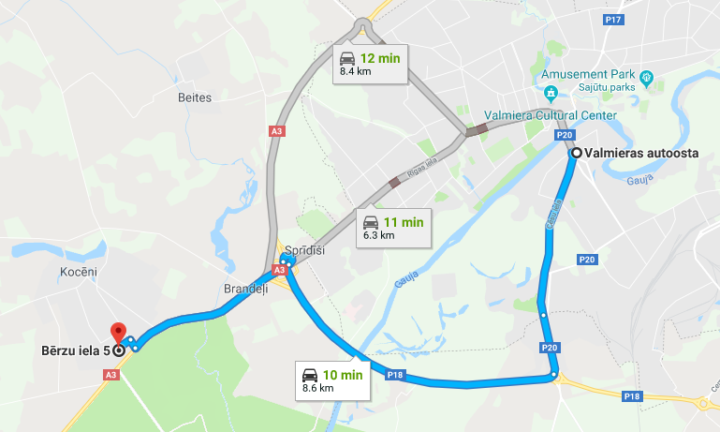
If you need more information:

*Aiva Saulīte-Liniņa
e-mail: aiva.saulite@llkc.lv
tel. +371 26592103
*Liene Feldmane
e-mail: liene.feldmane@llkc.lv
tel.+371 29334520

Emergency service: 112
Information about Valmiera
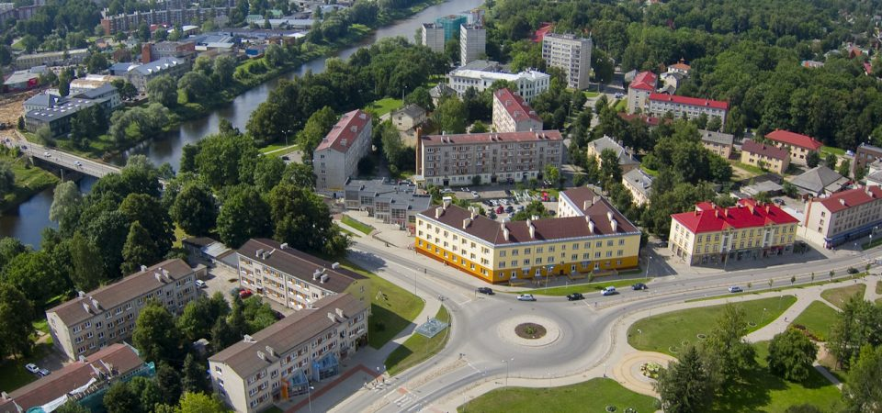
Valmiera is the 8th biggest city in Latvia and the administrative, educational, cultural and sports center of the Vidzeme region. As it is a city with a true entrepreneurial spirit, Valmiera is also the center for economic development of the Vidzeme region. It is a city of rich cultural heritage and active social life.
The year when the construction of the St. Simon’s Church was begun – 1283 – is considered to be the date, when the city was established.
Nowadays Valmiera is a city where one can find true historical pearls along with vast territories of unspoiled natural beauty, which, combined with industrial urban environment, creates a picturesque landscape and has all favorable preconditions for enjoyable living in the city.
More information: http://www.valmiera.lv/en/
Information about Cēsis
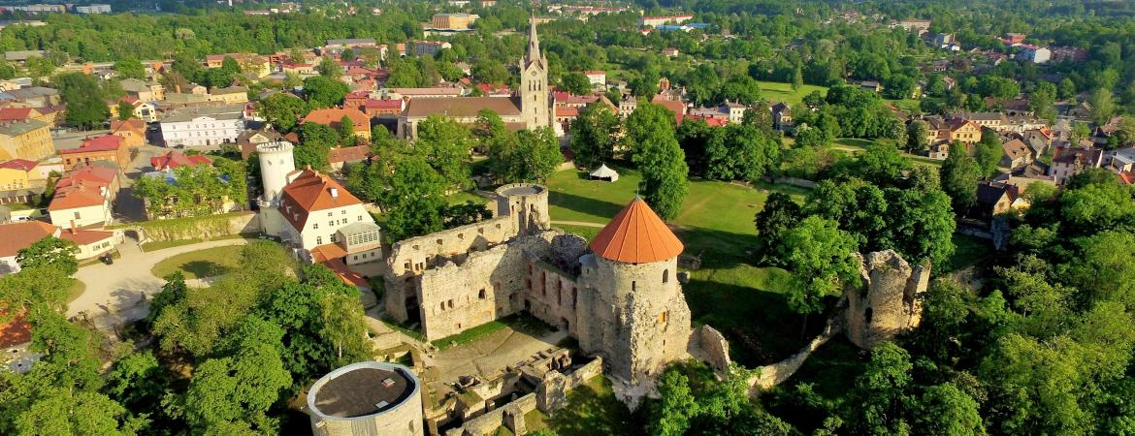
Cēsis is a charming city fusing together medieval history and contemporary culture.
The unique feel and hospitality of this 800-year-old city attracts tourists all year long – from the Baltic’s biggest ski resorts to the preserved medieval layout of the cobbled streets of Cēsis Old Town.
The rich cultural heritage stemming from as early as the 9th century lets anyone visiting feel like they are experiencing time travel. Spanning from Stone and Bronze Age dwellings at the Āraiši Lake Castle to the intricate interior motifs of the 18th century Cēsis New Castle, Cēsis is a time capsule waiting to be discovered.
But when it comes to the cultural life of the city, it is anything but ancient.
The Vidzeme Regional Concert hall proudly bears its name “Cēsis” and provides state-of-the-art modern, multifunctional facilities for world-class operas and concerts.
And when one has enjoyed enough of the city life, why not plunge into the pristine nature of Cēsis. The city itself is completely surrounded by the Gauja National Park named after the Gauja River, meaning lush, green meadows and serene forest trails are only moments away.
More information: http://www.cesis.lv/en/cesis-municipality/cesis-municipality-in-facts/

