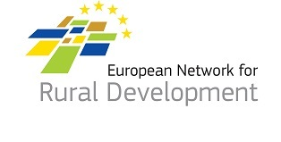
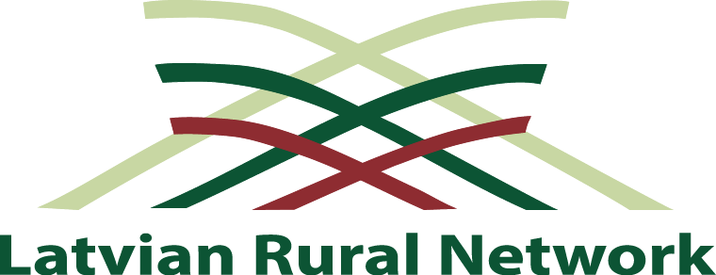

International seminar

Rural development and CLLD

12 -13th September 2018
Valmiera, Latvia

Background: The seminar reflects to the need to encourage rural area (space) stakeholders for being more innovative, to take advantages of possibilities and to be more strategic for regional and rural development.
Objective: To identify impulses (influencing factors) and possible solutions for unlocking the potential of development of the rural area.
Target groups: Managing authorities, national rural networks, local action group representatives.

September 12
Time | Agenda item
09.30-10.00 | Registration
10.00-14.00 | LEADER , European Regional Development Fund, Rural development plan project visits:  1. Circle Limbaži  2. Circle Smiltene  3. Circle Valmieras
14.00-15.00 | Lunch
15.00-18.30 | Project visits continues
19.10-19.50 | Time for transnational cooperation
20.00-21.30 | Social dinner

September 13
Time | Agenda item
08.00-09.00 | Registration at Valmiera Cultural Center
09.00-09.30 | Welcome and introductory remarks | Jānis Baiks, Chairmen of Valmiera City Council  Gints Kaminskis, Chairman of Latvian Association of Local and Regional Governments  Mārtiņš Cimermanis, Chairmen of the board of Latvian Rural Advisory and Training Centre  Edgars Linde,Head of the Latvian National Network Unit
09.30-09.50 | The development of rural space and interaction with the urban areas (Latvia 2030) | Māris Kučinskis, Latvian politician and the current Prime Minister of Latvia
09.50-10.10 | Centralization and regionalization, future challenges - in the context of regional and rural development | Raivis Bremšmits, Director of the Regional policy department of the Ministry of Environmental Protection and Regional Development of the Republic of Latvia
10.10-10.30 | Main challenges and objectives for rural development in Latvia | Liene Jansone, Director of the Rural Development Support Department of the Ministry of Agriculture of the Republic of Latvia
10.30-10.45 | Discussions and questions | Moderator
10.45.-11.45 | Value-based regional development | Ing. Josef Ober, Mayor of the Neue Stadt Feldbach, Austria
11.45-12.15 | Coffee break
12.15.-12.35 | LAG’s role in value-based region | Michael Fend, Association for the promotion of the Styrian volcanic land
12.35-12.55 | Feedback from thematic work of smart villages | ENRD Contact point
12.55-13.25 | Concept and development of Smart villages in Finland | Lauri Hyttinen, Network expert from Finnish National Rural Network
13.25-14.15 | Lunch
14.15-14.25 | Introduction to the working sessions | Moderator
14.25-15.55 | Parallel working sessions  -The development of rural space  To notice influencing factors which are important for rural and regional (including value-based) development, to identify necessary activities and objectives for joint advancement.  -Smart villages and it’s role in rural development  How to make it work? Identification of necessary instruments for making smart solutions.  -Joint action plan for rural development  Realization of common strategy by taking into account all possibilities, resources. How to use all possible funds for development processes including multi-funding approach?
15.55.-16.25 | Feedback session on the group discussions
16.25-17.00 | Coffee break and closing session

