LEADERFEST
30.5.-1.6.2017
Hlinsko
the Czech Republic

LEADERFEST 2017 Organisers invite rural actors and supporters to Hlinsko – a town of beautiful nature, history and of a rich cultural programme.

The LEADERFEST has already become an annual tradition with the aim to gather those people who are interested in rural development and practicing the LEADER method together in order to build the opportunity to exchange ideas with each other. This year, a special session is devoted to the cooperation to establish new connections, develop project ideas and kick off the project-related activities. From networking to action!

PROGRAM

TUESDAY, May 30 2017

- Arrival of participants
- 18:00 Welcome session in the brewery

WEDNESDAY May 31 2017

CONFERENCE ON THE RURAL DEVELOPMENT PROGRAMME

- 9:00 – 10:00 Registration
- 10:00 – 10:30 Welcome speech
- 10:30 – 11:30 Calls for proposals, award criteria, projects evaluation
- 11:30 – 12:00 Coffee Break
- 12:00 – 13:00 Cooperation projects – practice examples
- 13:00 – 14:30 Lunch
- 14:30 – 16:00 Workshops on Cooperation Projects, new bridges between potential partners
- 20:00 – 24:00 Reception

ACCOMPANYING EVENTS

- A market called Bethlehem:
Visit a market in the historical centre- a conservation area in the very centre of Hlinsko municipality lined along with a number of small timbered cottages, most of which still functioning as craft workshops for ceramics, weaving and engraving. The area offers numerous leisure activities as well – visit the municipal museum, the gallery, the baroque town hall or just have a cup of coffee in the cafeteria, lunch in a vege restaurant Mandala or a short hike around.
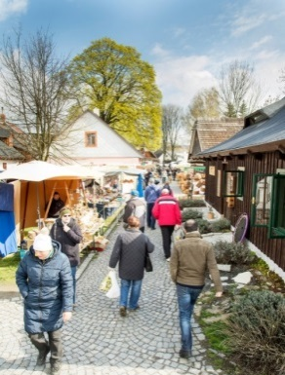
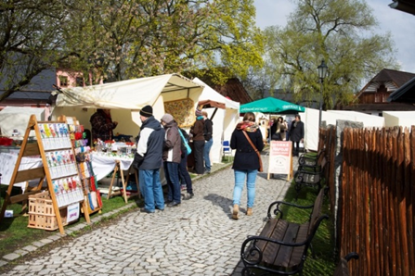
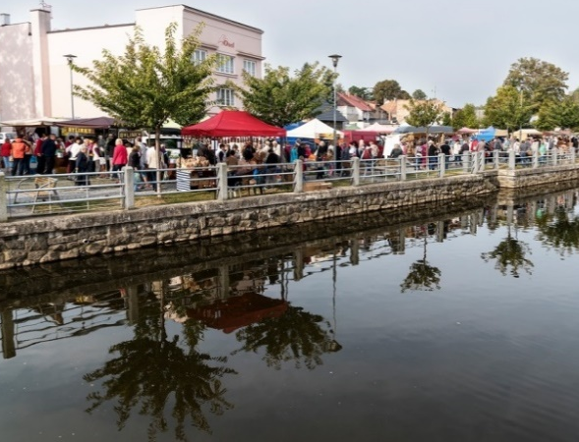
- Field Trips:
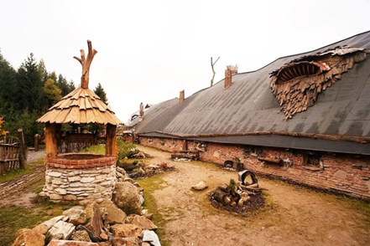
You can either choose one or combine two study trips together- to brewery with tasting sessions and/ to a project “Hell Certovina” which is a unique practice example on tourism and gastronomy.
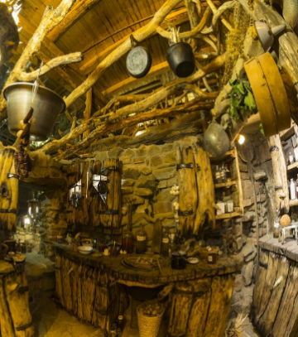
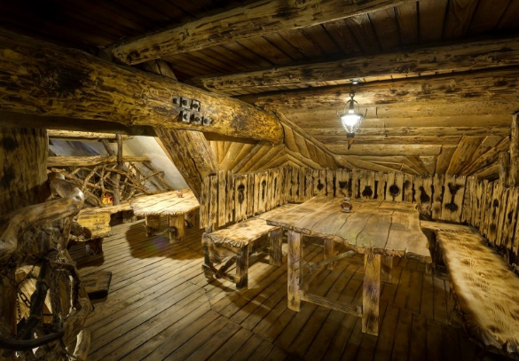
THURSDAY June 1 2017

SEMINAR ON LAGS AS PARTNERS FOR REGIONS

- 8:30 – 9:30 Registration
- 9:30 – 10:15 Integral Regional Operational Programme
- 10:15 – 11:00 Operational Programme Employment
- 11:00 – 11:30 Coffee Break
- 11:30 – 12:15 Operational Programme Environment
- 13:00 – 14:30 Closing remarks

ACCOMPANYING EVENTS

- Field Trips:
Take part in a guided tour to the town centre Bethlehem with the focus on the domestic production of handicrafts as the impetus for diversification and/or visit to the municipality of Vysocina awarded for most successful governance in 2017.

www.leaderfest2017.cz
Find us on FB:
Contact person:
Olga Ondráčková, manager LAG Hlinecko, ondrackova@mashlinecko.cz, phone number +420 777 111 078
TIPS FOR ACCOMMODATION
Hotel Styl 650 CZK single bed (breakfast included) 1 090 CZK double bed (breakfast included)
Booking: +420 469 311 532, +420 774 193 696
www.hotelstyl.eu
Distance to town centre: 1,4 km

Skirestaurant 400 - 450 CZK/night (breakfast included)
Booking: +420 777 789 899, Hotel Styl near by.
www.skirestaurant.cz
Distance to town centre: 1,4 km

Pension U Tvrze double beds, 2 apartments for 3 persons, 650 CZK/night (breakfast included)
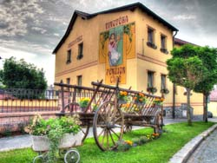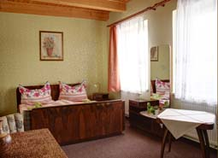
Booking: +420 604 309 333
http://www.penzionutvrze.cz
Distance to town centre: 230 m
Penzion Betlém 450 CZK/night (breakfast included)
Booking: +420 775 006 700
www.penzionbetlem.cz
In a city centre:

