International Training Program
Zhejiang
Sci-Tech
University
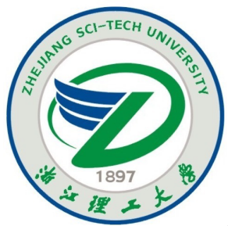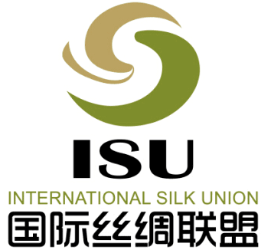
ITP-ZSTU:

Title of Workshop | Processing Technology and Innovation Design of Modern Silk Products
Funding Organization | Ministry of Science and Technology, P.R.China
Organizer | Zhejiang Sci-Tech University
Co-organizer | International Silk Union

Workshop Specification

This workshop is a part of the International Training Program funded by Ministry of Science and Technology (MOST), P.R. China, which will be held on Oct. 12-Oct. 26, 2016 in Zhejiang Sci-Tech University (ZSTU). The workshop aims to promote the further development of silk industry in the developing countries.
The workshop will implement a series of modular training courses to enable the participants to be better engaged in the silk design, technological innovation, quality control and management, as well as providing the opportunity for the participants to learn from each other.
Programs

Training Time：Oct. 12 - Oct. 26, 2016
Training Language: English
Training Location: Xiasha campus, ZSTU, Hangzhou, P.R. China
Training Courses: Silk fiber processing technology
Silk textile design
Silk textile weaving technology
Silk dyeing and finishing technologies
The detailed contents include current and development of Chinese silk industry, silk fiber and raw silk processing technology, pattern and color designs of silk fabrics, computer aided design (CAD) of silk Jacquard fabrics, modern silk-yarn preparation, modern silk-weaving equipment, silk dyeing and finishing technologies, and digital printing technique, etc.
Practical Courses: The participants will visit 4-5 well-known silk enterprises, take part in China International Silk Expo and visit China National Silk Museum, etc. The participants will have the opportunities to discuss and exchange their ideas with the invited industry officials, senior managers and technicians from the silk companies
Cultural Experiences：Hangzhou is one of the most popular tourism cities in China, famous for its natural scenes, historical and cultural heritages. More detailed information about Hangzhou is available at: http://en.gotohz.com/
Participants who have completed all courses and been qualified in assessment will be awarded a certificate issued by Ministry of Science and Technology, P.R.China
International Training Program
Zhejiang
Sci-Tech
University
ITP-ZSTU:

Candidate Requirement

Eligibility: Textile & silk technicians, enterprise managers, and relevant government & organization officials with a bachelor degree or above, without communication difficulty in English medium
Number of enrollment: 20
Registration website: https://168.160.11.33/student_login.aspx

All candidates should fill in the application form (in the attachment) and send it to ZSTU by E-mail with employment certificate （English version）and passport photocopy. The application form can be downloaded at: http://admission.zstu.edu.cn/en/Downloads.aspx

Important Dates
Application Deadline  Admission Letter Sending  Attendance Confirmation  Registration Date | June 20, 2016  July 1, 2016  Aug.10, 2016 (Information about flights and visa should be sent by participants for confirming the attendance)  Oct. 12, 2016
Financial Tips

- Free tuition
- Free accommodation from Oct. 12 - Oct. 26 during the training period
- Personal accident insurance (100 CNY/person) during the training period will be paid by MOST
- Allowance for living expenses (80 CNY/day) will be offered, excluding other personal expenses and international transport fee
Contacts

E-mail: yangziwang@zstu.edu.cn
chenjunjun_hz@zstu.edu.cn
Tel:+86-571-86843826
Fax:+86-571-86843255
Website:
http://www.cistc.gov.cn/Training/English/
http://www.zstu.edu.cn/english/index.html
http://admission.zstu.edu.cn/en/NewsDetail.aspx?Id=313&classid=4
Address: Silk Institute, School of Materials and Textiles, Zhejiang Sci-Tech University, 928 Second Avenue, Xiasha Higher Education Zone, Hangzhou 310018, P.R. China

